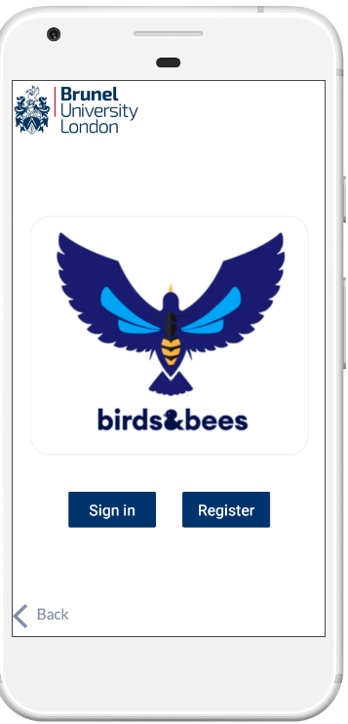

Access Full User interface via link <https://marvelapp.com/dd3cabe>